Shenley Fields Daycare &
Nursery School

Debit Card Policy

Policy for the Use of /Debit Purchase Cards

Purpose

To ensure that those with a purchase card use it in line with agreed financial controls, recommendations and legalities in a consistent way.

Rationale

To aid the Governor’s Finance Committee in monitoring the use of Debit/ Purchase cards.

Key Principles

The authorised officers appointed to control the use of credit cards are: Executive Head Teacher, Chair of Governors.

The use of the card is limited to purchases for the benefit of the school, and should only be used for purchases where an official order is not possible/ accepted. All purchases should be authorised by the Executive Head Teacher prior to being actioned.

The monthly expenditure limits should not be exceeded –

David Aldworth = £25,000 with a single transaction limit of £10,000
Louise Shepherd = £25,000 with a single transaction limit of £10,000

Use and Management of Debit Cards

The ATM (cashpoint), should only be used to change the PIN number of the card. Schools must not attempt to withdraw cash.

A card holder must have the nominated budget holder’s approval before goods and services can be purchased using the Debit Card.

Card holders should try to plan ahead. Check to see if establishments do accept Debit Cards, this may avoid having to use personal money. As Debit Cards are Visa Cards they can, therefore, be used with any supplier or outlet where the ‘Visa’ sign is shown.

Card holders must retain all receipts/delivery notes for all transactions made whether in person or via the internet, and attach them to the Debit Card Purchase Authority Form.

Any gift vouchers and gift items that are purchased using the Debit Card must be supported by additional authority from the Executive Head Teacher and Chair of Governors. See ‘Gifts and Hospitality’ chapter.

The Debit Card must not be shared with other staff.

The consequences of mis-use of the Debit Card will be cancellation of the holder’s card and, potentially, an instigation of disciplinary proceedings.

Conditions on the Use of Debit Cards

Only the Card Holder may use the Debit Card.

The monthly card limit is set at £25,000. Dependent upon the school’s requirements this amount can be changed by the Card Holder’s line manager and approval should be sought prior to requesting an increase in the monthly limit

A single transaction limit is set at £10,000. Dependent upon the school’s requirements this amount can change either on a permanent basis or if there is a requirement for a one off purchase the limit can be increased on a temporary basis by the Card Holder’s line manager. Approval should be sought prior to requesting a permanent increase to the single transaction limit.

Card Holders should treat the Debit Card with the same caution as if it were their own personal card and keep it secure at all times

If the card is lost or stolen the Card Holder should contact the Bank
immediately 24/7 Telephone Number: 0800 096 9779 (within the UK) or +44 1702 278 270 from abroad
from outside the UK). The card will be cancelled by the Bank and the Debit Card Administrator should be informed

Card Holders must never give card details over the telephone to anyone other than bona fide companies. No person or organisation will contact a Card Holder asking for card details but there are fraudsters who may try to obtain details in this way.

Whilst the Debit Card is embossed with the Card Holder’s name, the account, and therefore the liability, rests with the Local Authority. Consequently, there is no impact on the Card Holder’s personal credit status.

Card Holders must contact the Card Administrator with any changes in circumstances that will impact on the use of the Debit Card. If the Card Holder is leaving, the card must be given to the Line Manager to cut up. The Line Manager should also request card to be cancelled at the bank and that the card will be destroyed.

If any of the goods purchased on the card are faulty or the wrong goods ordered, Card Holders should contact the supplier to arrange a credit or an exchange. Card Holders should record credits on the Individual Debit Card Purchase Authority Form in the same way as the original purchase.

If transactions appear on the Statement but goods have not been received Card Holders should contact the supplier to obtain proof of delivery.

How to Purchase Goods and Services Using a Debit Card

Buying Goods and Service in Person from the Supplier

The Card is a Visa debit card and therefore acceptable for use where the Visa sign is shown.

When paying for goods the Card Holder should use the PIN and Chip facility wherever possible.

Card Holders should check that the amount being charged is correct.

When entering the PIN number Card Holders must ensure that this is carried out as securely as possible.

Card Holders must obtain a receipt from the supplier, including a VAT receipt, where applicable.

Card holders must never give the PIN number to a supplier and must never write it down. PIN numbers can be changed at ATM machines and it is advisable not to use the same numbers as for personal cards.

Buying Goods and Services over the Telephone or Internet

When buying over the telephone or internet Card Holders may need to quote
the Company details as follows:

If you have a School Debit Card:
Card Name : This should read exactly as it is on the card
Company Name: Shenley Fields Nursery School
Company Address: Woodcock Lane, Northfield, Birmingham B31 1BU
The schools own address will be the delivery address – Shenley Fields Nursery School, Woodcock Lane, Northfield, Birmingham B31 1BU

The Card Holder will have to quote the name as displayed on the card together with the 16-digit card number, the 4-digit expiry date and the 3 digit security number on the reverse of the card. Give a clear description of the goods and services required.

Agree the price – net amount, gross amount and VAT amount. Check delivery or carriage charges.

Obtain a delivery date and agree a delivery location.

8.0 Internet Ordering

A formal request to use internet ordering should be made to the Executive Head Teacher for their approval. The request should explain why the school wishes to use this method of ordering rather than the usual method.

Read the ‘Internet Use Policy’ and remember that internet use is monitored as part of the ‘Internet Monitoring Standard’.

It is recommended that internet orders are placed only with reputable companies, ideally those with whom the school has dealt with in the past. Where goods or services are to be purchased via the internet it is recommended that schools check supplier details before an order is placed, for example:

- The internet website should refer to the supplier’s name and
address. A ‘UK’ internet address does not always mean that the supplier is
UK based. A supplier’s website will include information relating to the
company’s term and conditions of trading and this information should be
checked by the school before placing an order
- https at the beginning of the web address signifies that the site is secure
- It is recommended that transactions take place under UK jurisdiction where
normal forms of redress are available to solve problems or disputes
regarding faulty goods or non-delivery of goods
- A full description of the goods or services that are to be purchased is made available
- The prices include relevant taxes
- Delivery costs and arrangements are made clear
- How long the price will stay valid
- How to make the payment
- The rights and procedures for cancelling orders
- If it is a service that is being procured, how long is the school committed for
- That the contract in law is between the school/authority and the supplier
and not between an individual and the supplier
Once schools are happy with the details and the terms and conditions of the supplier then an order can be placed via the internet

The authorised member of staff placing orders using the internet should be aware of the relevant guidelines and certify their understanding of them and agreement to abide by them.

Whilst it is recognised good practice to raise an official confirmation order at the time of placing an internet order it is accepted that this can create significant administrative difficulties. Therefore, a nominal payment should be recorded within 24 hours of the purchase being made. The nominal payment will be reconciled against the bank statement.

It remains the responsibility of the budget holder to ensure that there are sufficient resources available within the relevant cost centres to cover the costs of all orders placed. An appropriate system must be established to enable the budget holder to monitor all outstanding commitments against the cost centre.

Where an internet order is placed a copy of the order should be printed off and retained by the school. This should be signed by an authorised officer independent of the ordering raising process

The conditions of purchase should be notified to the supplier for all orders placed

Internet orders must not be placed for personal use.

Debit Cards and VAT

Card Holders must endeavour to ask for a VAT receipt or invoice and check that the VAT element can be clearly identified. This is because the Local Authority can recover all VAT on the purchases made providing it satisfies the requirements of Her Majesty’s Revenue and Customs (including specific inclusions for VA Schools)

Appendix D gives examples of VAT liability to expect for some common purchases.

If a VAT receipt/ invoice cannot be obtained schools will not be able to recover any of the VAT incurred. Card Holders must bear in mind that even if something appears to be good value, if the VAT cannot be recovered it may prove to be more expensive.

When purchasing over the internet an email is often sent to confirm the purchase. This is generally not a VAT receipt or invoice. When purchasing goods over the internet, in addition to a confirmation email, Card Holders must take reasonable steps to gain a VAT receipt or invoice in order to comply with HMRC VAT rules and regulations

Debit Card Records

Card Holders must obtain a receipt for all purchases

Delivery notes should be obtained where possible

All documents should be kept safe and should be attached to the Debit Card Purchase Authority Form

Debit Card Purchase Authority Form

An individual Debit Card Purchase Authority Form must be kept of all transactions carried out with the Debit Card

Appendix C is a template for the Authority Form

All transactions shown on the Debit Card Purchase Authority Form are to be checked and reconciled against the weekly/ monthly bank statement by DRB (bursary service). They also undertake VAT returns.

Card Holders are advised to retain any receipts which do not appear on the Statement as they are likely to appear on the next Statement.

Card Holders should query any transactions showing on the Statement for which there is no record, receipt or recollection.

Card Holders should complete the Debit Card Purchase Authority Form, and sign and date to confirm that it has been checked and agreed.

Schools must retain all Statements, original receipts and Debit Card Purchase Authority Forms for a minimum of 6 years.

Statements, original receipts and Debit Card Purchase Authority Form records may be subject to inspection at any time and must be provided, upon request, for inspection by Audit or Accounts Payable.

Appendix D is a template for the Transaction Logs

A summary log of transactions detailing all the expenditure on the debit cards is to be completed monthly for each debit card, reviewed against the bank statements, and the summary log should be signed and dated by the both the cardholder and the authorising manager in a timely manner.

Authorising Manager for the card held by David Aldworth: Sean Delaney (Chair of Governors)
Authorising Manger for the card held by Louise Shepherd: David Aldworth (Executive Head Teacher)

Appendix E shows goods typically subject to VAT and goods not typically subject to VAT

Approved by Chair’s Actions: 5.3.2024
Adopted by Local Committee: 18.3.2024
Adopted by the Full Governing Body: 29.4.2024
Date for next renewal: Spring Term 2025

Signed: ____________________________ Sally Andrews
Chair of Local Committee

Signed: ____________________________ Sean Delaney
Chair of Governors

Signed: ____________________________ David Aldworth
Executive Head Teacher

APPENDIX A

Schools are not obligated to use contracted suppliers and therefore they can
purchase from whichever supplier they chose to get the best value.

EXAMPLES OF THE TYPES OF EXPENDITURE ACCEPTED ON THE PURCHASE CARD INCLUDE:

- Taxis, car parking, coach, train and air travel (following BCC procedures)
- Subsistence (if paid by purchase card staff must NOT claim again through
payroll). Please see BCC’s new guidance on claiming subsistence – 24 hour rule – ‘Payroll and Pensions’ chapter)
- Fuel for school minibuses (Please note that the card holder is required to obtain a VAT receipt for all fuel purchases in addition to the transaction receipt)
- Trips to theme parks, cinemas or theatre and works of art
- Stamps, publications, external course fees, books and subscriptions
- Vehicle tax and vehicle maintenance
- Foreign Payments
- TV Licenses

Please note that you are not obliged to use BCCs contracted suppliers

APPENDIX B

ITEMS THAT CAN NOT BE PURCHASED USING THE DEBIT/PURCHASE
CARD

- Goods and services for the card holder’s personal use
- Items from merchant categories that schools are blocked from using.

APPENDIX C
DEBIT CARD PURCHASE AUTHORITY FORM

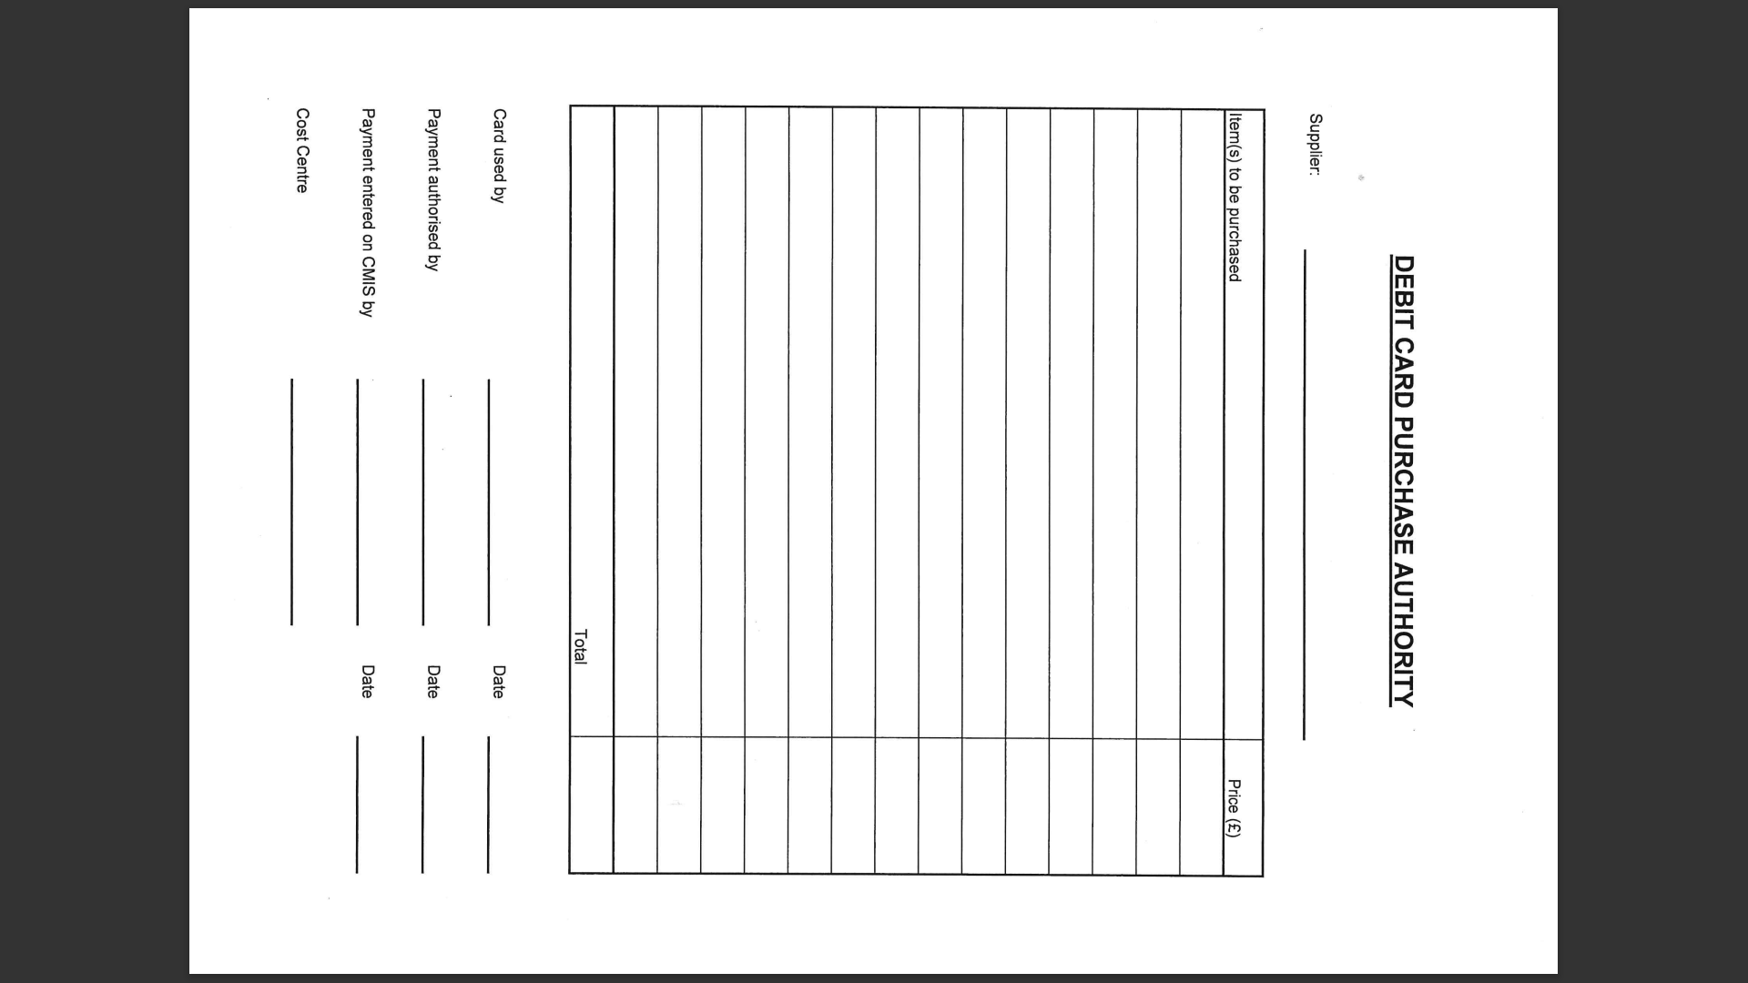

Date | Company Paid | Amount | Email Authorisation Received | Authorising Manager’s Signature | New Total
APPENDIX D - TRANSACTION LOGS
Card Holder: Louise Shepherd
Authoring Manager: David Aldworth (Executive Head Teacher)
Card Limits: £25,000 per calendar month. Single Transaction Limit: £10,000
Monitoring Period: From ______________ To: ________________

Date | Company Paid | Amount | Email Authorisation Received | Authorising Manager’s Signature | New Total
Card Holder: David Aldworth
Authoring Manager: Sean Delaney (Chair of Governors)
Card Limits: £25,000 per calendar month. Single Transaction Limit: £10,000
Monitoring Period: From ______________ To: ________________

APPENDIX E

TYPICALLY SUBJECT TO VAT | TYPICALLY NOT SUBJECT TO VAT
Petrol | Public Transport
Luxury Foods (confectionary, chocolate  biscuits, beverages other than tea/coffee) | Basic food (groceries)
Hot Foods (takeaway, restaurant) | Books and Newspapers
DVS’s | Gift Vouchers
Toys and Games | Stamps
Adult Clothing | Children’s Clothing
Leisure Activities (theatre, cinema, bowling, theme parks) | Legal Documents (car tax)
Courses provided by the commercial sector | Courses provided by the Public Sector
Fixtures, fittings and equipment | Insurance
Off street car parking | On street car parking
Repairs

See ‘Value Added Tax’ chapter

